Gary Chen 12/13/2020

**Final Project Deliverables**

**Part 1:**

My project will be building a database based on the data that I have been collecting on my workouts and health habits for another class. It would be cool to model this information into a database. For building out this data base, I will include more people(athletes) who are following the same program and tracking the same entities and attributes. Building a data base for my individual habit does not generate enough data points and does not give enough zero to many relationships.

**Starting Strength Database:**

“Starting Strength” is the exercise program that will be the measures of the continuous output of this project. The workout program has 2 different workouts which each will consist 3 out of the 4 exercises. Every workout will involve squatting and deadlifting but alternating bench pressing and military pressing between each work out. Workout A consists of squat, bench, and deadlift. Workout B consists of squat, military press, and deadlift. The number of pounds that lifted in each exercise of the working sets will be recorded. Here are some of the logistics of the program.

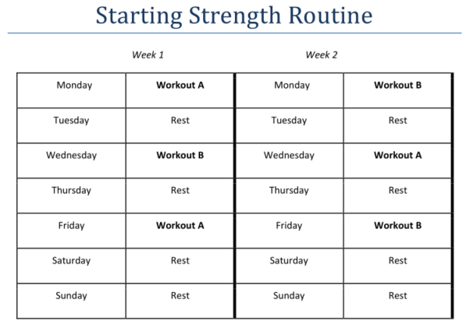

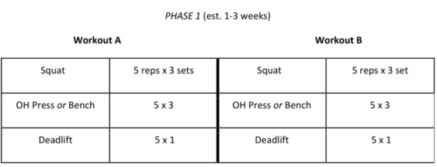

Each athlete starts the program at the same time (October 12th, 2020). In addition to tracking my workouts, there will be tracking on what time the workouts begin (morning, noon, evening), which gym the athlete goes to (etc…UFC/NYSC/LA FITNESS) and duration of stretching. There will also be tracking of daily data on the amount of sleep each day, if a CPAP machine is used that night, if the daily calorie goals(yes/no) are met, and alcohol intake. Every week the athletes’ body weight gets recorded and if they saw a physical therapist during the week.

* I left out the which gym the athlete is in for the updated model. It was not super relevant in answering any of the data questions.
* I also left out CPAP usage since not everyone requires a CPAP machine, and it does not help with comparisons.

**Conceptual Model- ERD:**

|  |  |
| --- | --- |
| **Entity** | **Attributes** |
| Workout | Athlete name [rc] |
|  | workout number [rd] |
|  | Date[r] |
|  | Start Time [r] |
|  | Gym [r] |
|  | Workout routine[r] |
|  | Stretch Duration [r] |
|  | Squat [r] |
|  | Bench [d] |
|  | Military Press [d] |
|  | Deadlift [r] |
| Athlete | name [rc] |
|  | email address [ru]  gender |
| Daily Habits | Date [r] |
|  | Hours of sleep from night before [r] |
|  | CPAP usage [d] |
|  | Calories [r] |
|  | Alcohol Intake [r] |
| Weight | Week [r] |
|  | athlete name[rc] |
|  | weight(lbs) [r] |
| Physical Therapy | PT Session [r]  Week[r] |
|  | Date [r] |
|  | Treatment area [m] |

-Each athlete gets his/her daily sleeping and eating habits recorded.

-An athlete may or may not work out on a particular day. Depending on which work out they do, either Bench or Military Press numbers get recorded.

-Every week, an athletes’ body weight gets recorded. An athlete may or may not get PT during that week.

* one athlete to one or many daily habits gets recorded.
* one athlete to zero or many workouts
* zero or one athlete to zero or many physical therapy sessions
* one athlete to one or many weigh-ins
* Zero or one bench to zero or one military press (determined by workout)
* one week of weight ins to Zero or many sessions of physical therapy

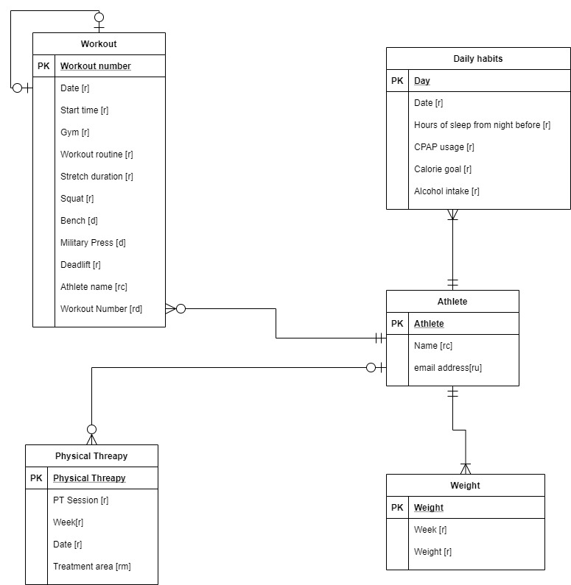

**Logical Modeling:**

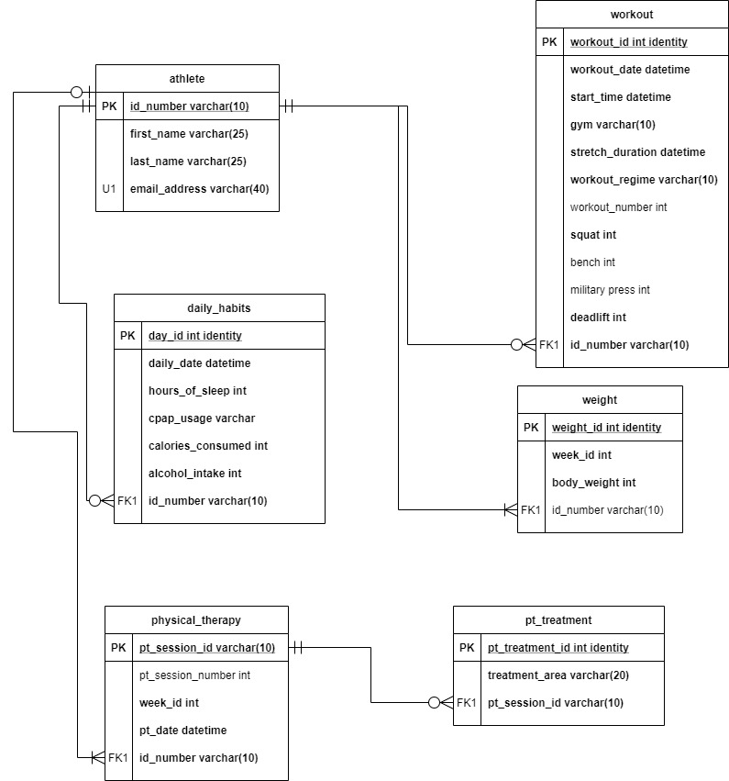

**Data questions:**

* What is the average amount of sleep that each athlete gets in a night?
* What are the maximum pounds that each athlete lifted for each exercise in the program?
* Which athlete ate the most calories in the 8-week time span?
* Which athlete worked out the most? (most workout sessions)
* What was the most common body part that the athletes seek treatment for?

**PART 2: New Rules/ Changes**

- the athletes height and gender will be added to the athlete table

- CPAP usage column from daily habits table will be taken out

- Gym and workout number columns will be taken out of workout table

- Workout table will be split into workout session and working set pounds tables to further normalize the data

- Workout duration is added to the workout session table

- Workout duration and stretch duration will be varchar types

- The workout session primary key will be changed from int to varchar. Format rules for workout id will follow as first letter of first name, then first 2 letters of last name with a digit key, and then workout number

-EX: athlete is Gary Chen, and it is his first workout. = gch1-0001

**Updated Logical Modeling:**

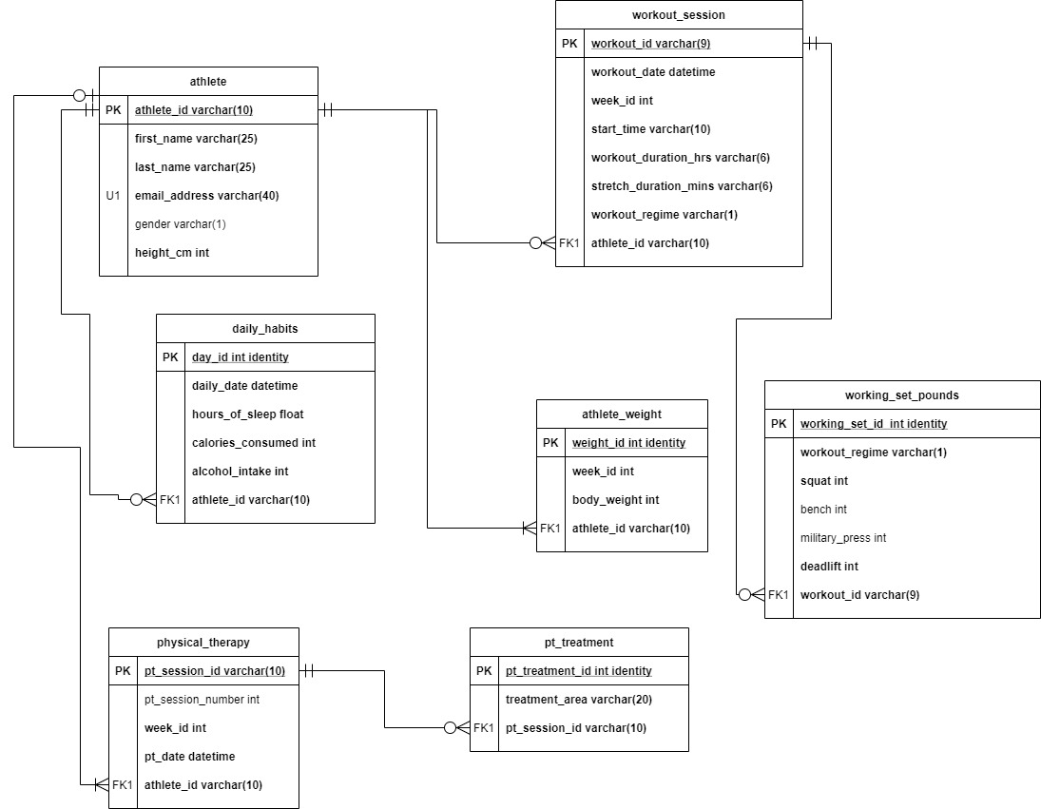

* On the workout sessions table, I had to change the workout duration hrs and stretch duration mins columns to string instead of date time. I had trouble finding the right dummy data when I was populating those columns. The best solution I can find was to convert it to string to make my database work. This is not the best solution because we cannot do calculations for those columns. At least we get an idea of what the duration and stretch time were for a specific workout. These duration values should have been converted to whole minutes or seconds before being implemented into SQL.

**Data Manipulation:**

* I created a view to include all workout A regime into one table with the athlete’s full names and other workout session details. This is a better view of our data to not include the correspond null values from the military press column.

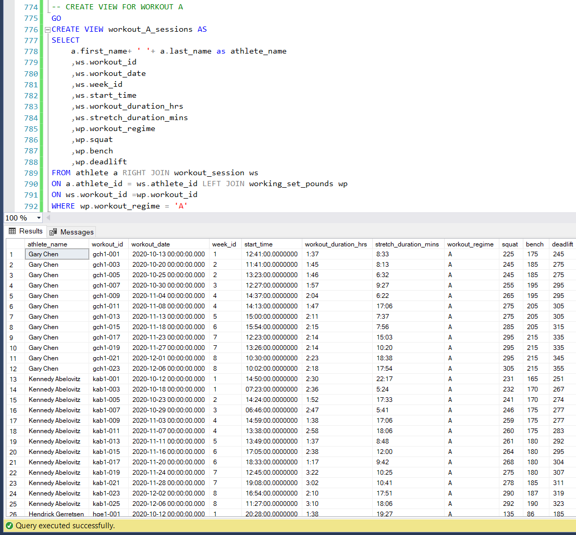

* I created a view to include all workout B regime into one table with the athlete’s full names and other workout session details.

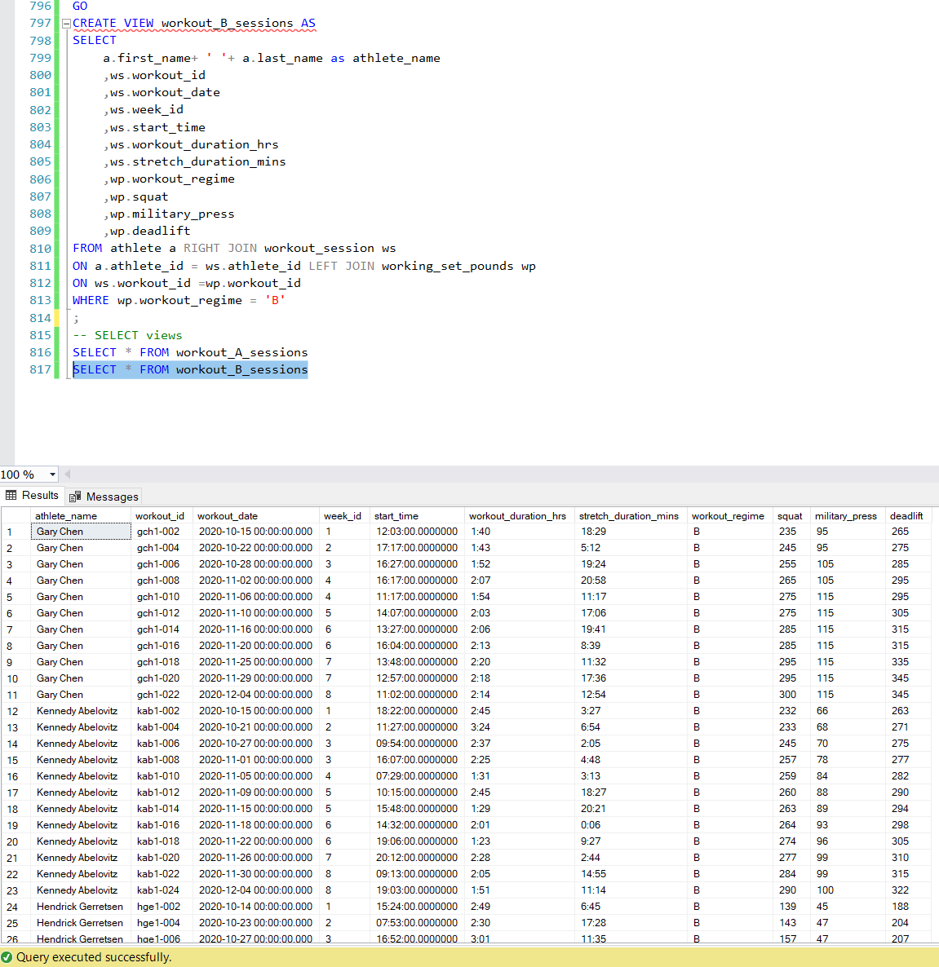

**Answering Data Questions:**

* **What is the average amount of sleep that each athlete gets in a night?**

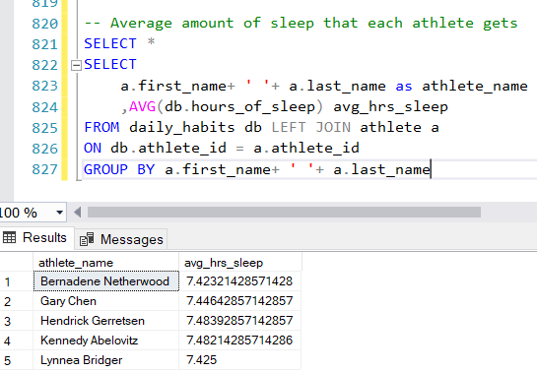

-It seems like every athlete gets around the same amount of sleep. 7.4 hours of sleep is adequate since most adults require 7-8 hours of sleep.

* **What are the maximum pounds that each athlete lifted for each exercise in the program?**

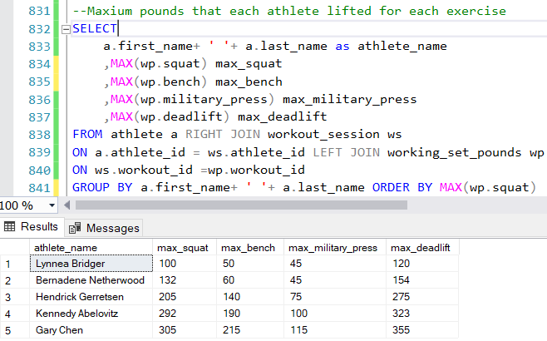

-This query returns the maximum weights that each athlete lifted for each exercise.

* **Which athlete ate the most calories in the 8-week time span?**

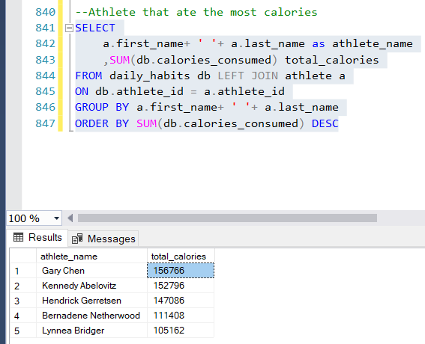

-Gary Chen ate the most calories in this time span. He was also the strongest athlete out of the 3. The number of calories he ate probably contributed to his weightlifting output.

* **Which athlete worked out the most? (most workout sessions)**

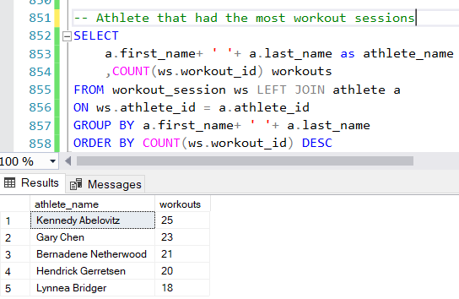

-Kennedy Abelovitz logged the most workouts out of all the athletes.

* **What was the most common body part that the athletes seek treatment for?**

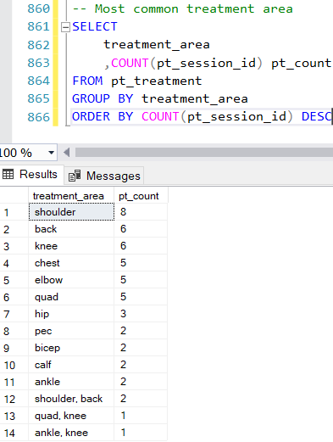

-Shoulder injuries were the most common injury. Back and knee were other common injuries.

**Implementation: Tableau**

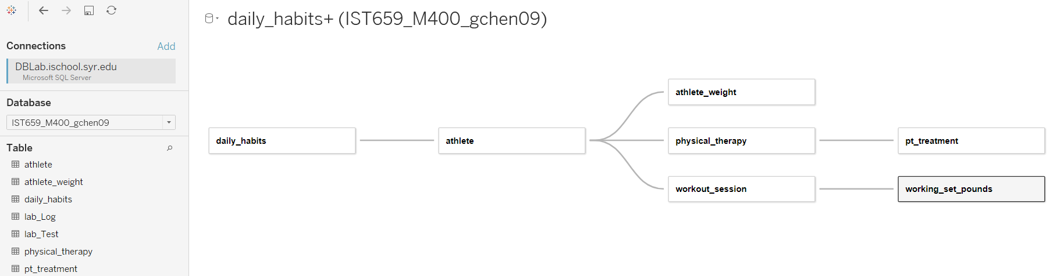

I connected Tableau directly to our SQL server, DBLab.ischool.syr.edu. On the data source tab, I am connected to my own database IST659_M400_gchen09 with access to all the tables in there. Since the new Tableau update, we can do more than just joining tables. We can create relationships between each table by using the primary or foreign keys as the criteria. After creating these connections, I can build many kinds of charts, graphs, or dashboards with my data. I recreated a simple graph to answer which athlete ate the most total calories from October 12th, 2020 through December 6th, 2020.

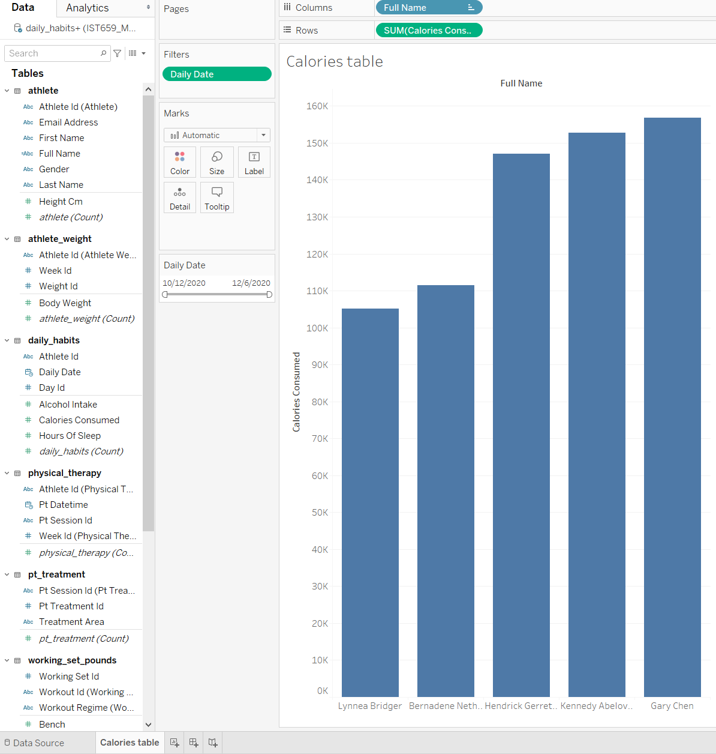

On the left side underneath the Tables field, is where all the column attributes from my project are. It is easy to choose which dimensions or measures I want to work with to answer any data question. Tableau also allows me to put in filters like a date range. I can answer additional questions with that filter such as how many calories the athletes consumed on the first week or on a given day.

**Reflection:**

At the beginning of the project, I thought I could create just a database for my own workout habits. As I started to learn more about SQL and database relationships, that concept was not going to make a very good database. I needed more relationships and a more granular concept than just for one person. I included multiple athletes in the project to create more relationships as shown by my ERD.

I had some experience in querying with SQL. I thought knowing the syntax to table and view creation was enough to build a database. This class and project have taught me building a database requires a lot of conceptual thinking and planning. Mapping and drawing out the diagrams are important parts to the process. In the future, my approach to SQL and creating tables will be more than just writing the code. I will focus more on relationships between tables and normalizing the dataset. I will also be mindful of creating the database with room to grow and add more data into it. I learned to see databases as a tool to organize data and find answers to business problems. The foundation of databases decides if the database will be successful in the long run.

**Summary:**

The project scope is still very similar to part 1 deliverables. I adjusted or took some of the columns out. I did further normalization on the workout table. It was split into workout session table and working set pounds table. The workout session primary key was changed from int to varchar. On the workout sessions table, the workout duration hrs and stretch duration mins columns had to be varchar types. It was the only solution that I could think of to make my database work with the dummy data. This is a flaw in the database because we cannot do calculations for those columns. In the future, I will be more mindful in finding better ways to format time duration values into SQL. I should have converted the time duration values into whole minutes or seconds.

I used Tableau as an implementation tool because of its strength in producing visualizations. SQL cannot produce graph or actionable filters. Tableau and SQL have very good synergy. SQL feeds the data and fields to Tableau where it uses those inputs to produce graphs and visualizations. It allows users to further exam the dataset. I used functions, aggregate, and joins between table in SQL to answer the data questions. SQL queries returned the raw numbers for the answers to the questions. I was able to create a bar chart on Tableau to answer the question on which athlete consumes the most calories. Tableau helped better conceptualize on how much of a gap was between the athletes in their calorie consumption. Numbers give you the information, but visualizations tell you a story. Tableau has those tools and can tell you a story of any SQL dataset.

**SQL query:**

/*

IST659 Starting Strenght Porject

Author: Gary Chen

*/

-- DROP TABLES

DROP TABLE IF EXISTS working_set_pounds

DROP TABLE IF EXISTS workout_session

DROP TABLE IF EXISTS athlete_weight

DROP TABLE IF EXISTS pt_treatment

DROP TABLE IF EXISTS physical_therapy

DROP TABLE IF EXISTS daily_habits

DROP TABLE IF EXISTS athlete

-- CREATE TABLES(in reverse order of drop)

CREATE TABLE athlete (

athlete_id varchar(10) PRIMARY KEY,

first_name varchar(25) NOT NULL,

last_name varchar(25) NOT NULL,

email_address varchar(40) UNIQUE,

gender varchar(1),

height_cm int,

-- Constraints

CONSTRAINT CK_gender CHECK(gender IN ('M','F','T',NULL))

)

CREATE TABLE daily_habits(

day_id int identity PRIMARY KEY,

daily_date datetime NOT NULL,

hours_of_sleep float NOT NULL,

calories_consumed int NOT NULL,

alcohol_intake int NOT NULL,

athlete_id varchar(10) NOT NULL,

-- Constraints

CONSTRAINT FK1_athlete_id FOREIGN KEY (athlete_id) REFERENCES athlete(athlete_id)

)

CREATE TABLE physical_therapy(

pt_session_id varchar(10) PRIMARY KEY,

week_id int NOT NULL,

pt_datetime datetime,

athlete_id varchar(10) NOT NULL,

--Constraints

CONSTRAINT FK2_athlete_id FOREIGN KEY (athlete_id) REFERENCES athlete(athlete_id)

)

CREATE TABLE pt_treatment(

pt_treatment_id int identity PRIMARY KEY,

treatment_area varchar(20) NOT NULL,

pt_session_id varchar(10) NOT NULL,

--Constraints

CONSTRAINT FK1_pt_session_id FOREIGN KEY (pt_session_id) REFERENCES physical_therapy(pt_session_id)

)

CREATE TABLE athlete_weight(

weight_id int identity PRIMARY KEY,

week_id int NOT NULL,

body_weight int NOT NULL,

athlete_id varchar(10) NOT NULL,

--CONSTRAINT

CONSTRAINT FK3_athlete_id FOREIGN KEY (athlete_id) REFERENCES athlete(athlete_id)

)

CREATE TABLE workout_session(

workout_id nvarchar(10) PRIMARY KEY,

workout_date datetime NOT NULL,

week_id int NOT NULL,

start_time time NOT NULL,

/* Had to change workout_duration_hrs and stretch_duration_mins

to string type because dummy data gave formatting errors when trying to insert data into database.

Can't do calculations on these columns with that format, but at least we get an idea.

I was in too deep in and couldn't change the dummy data format.

*/

workout_duration_hrs varchar(6) NOT NULL,

stretch_duration_mins varchar(6) NOT NULL,

workout_regime varchar(1) NOT NULL,

athlete_id varchar(10) NOT NULL

--CONSTRAINT

CONSTRAINT FK4_athlete_id FOREIGN KEY (athlete_id) REFERENCES athlete(athlete_id),

CONSTRAINT CHK1_workout_regime CHECK(workout_regime IN ('A','B'))

)

CREATE TABLE working_set_pounds(

working_set_id int identity PRIMARY KEY,

workout_regime varchar(1) NOT NULL,

squat int NOT NULL,

bench int,

military_press int,

deadlift int NOT NULL,

workout_id nvarchar(10) NOT NULL,

--CONSTRAINT

CONSTRAINT FK1_workout_id FOREIGN KEY (workout_id) REFERENCES workout_session(workout_id)

)

-- Populate (INSERT INTO) Tables

-- athlete table

insert into athlete (athlete_id, first_name, last_name, email_address, gender, height_cm) values ('woa734h0l', 'Gary', 'Chen', 'gchen0@fastcompany.com', 'M', 180);

insert into athlete (athlete_id, first_name, last_name, email_address, gender, height_cm) values ('ygk491l0m', 'Kennedy', 'Abelovitz', 'kabelovitz1@domainmarket.com', 'M', 185);

insert into athlete (athlete_id, first_name, last_name, email_address, gender, height_cm) values ('drw449q2y', 'Hendrick', 'Gerretsen', 'hgerretsen2@yahoo.co.jp', 'M', 173);

insert into athlete (athlete_id, first_name, last_name, email_address, gender, height_cm) values ('inv129a6q', 'Bernadene', 'Netherwood', 'bnetherwood3@webeden.co.uk', 'F', 159);

insert into athlete (athlete_id, first_name, last_name, email_address, gender,height_cm) values ('fej383w5e', 'Lynnea', 'Bridger', 'lbridger4@shop-pro.jp', 'F', 153);

--daily habits table

INSERT INTO daily_habits VALUES

('2020-10-12 00:00:00',8,2765,0,N'woa734h0l'),

('2020-10-13 00:00:00',8.5,2857,0,N'woa734h0l'),

('2020-10-14 00:00:00',8.5,2531,0,N'woa734h0l'),

('2020-10-15 00:00:00',8,2593,0,N'woa734h0l'),

('2020-10-16 00:00:00',7,2810,8,N'woa734h0l'),

('2020-10-17 00:00:00',5.5,2811,7,N'woa734h0l'),

('2020-10-18 00:00:00',4,2721,0,N'woa734h0l'),

('2020-10-19 00:00:00',10,2649,0,N'woa734h0l'),

('2020-10-20 00:00:00',9,2688,0,N'woa734h0l'),

('2020-10-21 00:00:00',7,2648,0,N'woa734h0l'),

('2020-10-22 00:00:00',8,3070,0,N'woa734h0l'),

('2020-10-23 00:00:00',7.5,2901,3,N'woa734h0l'),

('2020-10-24 00:00:00',8,2813,4,N'woa734h0l'),

('2020-10-25 00:00:00',7,2770,0,N'woa734h0l'),

('2020-10-26 00:00:00',8,3075,0,N'woa734h0l'),

('2020-10-27 00:00:00',6.25,2960,0,N'woa734h0l'),

('2020-10-28 00:00:00',7.25,2957,0,N'woa734h0l'),

('2020-10-29 00:00:00',8,2757,0,N'woa734h0l'),

('2020-10-30 00:00:00',7,2870,0,N'woa734h0l'),

('2020-10-31 00:00:00',8.25,2694,9,N'woa734h0l'),

('2020-11-01 00:00:00',6.25,3079,0,N'woa734h0l'),

('2020-11-02 00:00:00',7.5,3024,0,N'woa734h0l'),

('2020-11-03 00:00:00',8.5,2727,0,N'woa734h0l'),

('2020-11-04 00:00:00',6,2874,0,N'woa734h0l'),

('2020-11-05 00:00:00',6.5,2523,0,N'woa734h0l'),

('2020-11-06 00:00:00',6.5,2791,0,N'woa734h0l'),

('2020-11-07 00:00:00',6,2713,0,N'woa734h0l'),

('2020-11-08 00:00:00',7.5,2906,1,N'woa734h0l'),

('2020-11-09 00:00:00',6,2939,0,N'woa734h0l'),

('2020-11-10 00:00:00',8,2984,0,N'woa734h0l'),

('2020-11-11 00:00:00',9,2781,0,N'woa734h0l'),

('2020-11-12 00:00:00',7,2830,0,N'woa734h0l'),

('2020-11-13 00:00:00',6.5,2730,5,N'woa734h0l'),

('2020-11-14 00:00:00',7,2651,0,N'woa734h0l'),

('2020-11-15 00:00:00',9,2867,0,N'woa734h0l'),

('2020-11-16 00:00:00',7.5,2618,0,N'woa734h0l'),

('2020-11-17 00:00:00',8,2845,0,N'woa734h0l'),

('2020-11-18 00:00:00',7.5,2716,1,N'woa734h0l'),

('2020-11-19 00:00:00',8,2789,0,N'woa734h0l'),

('2020-11-20 00:00:00',8.5,2867,1,N'woa734h0l'),

('2020-11-21 00:00:00',5.5,2778,2,N'woa734h0l'),

('2020-11-22 00:00:00',7.5,2905,0,N'woa734h0l'),

('2020-11-23 00:00:00',9,3127,0,N'woa734h0l'),

('2020-11-24 00:00:00',7.5,2543,0,N'woa734h0l'),

('2020-11-25 00:00:00',7,2530,0,N'woa734h0l'),

('2020-11-26 00:00:00',7,2960,0,N'woa734h0l'),

('2020-11-27 00:00:00',7,2519,4,N'woa734h0l'),

('2020-11-28 00:00:00',8,2602,0,N'woa734h0l'),

('2020-11-29 00:00:00',6.5,2523,1,N'woa734h0l'),

('2020-11-30 00:00:00',8.5,2868,0,N'woa734h0l'),

('2020-12-01 00:00:00',7.5,3068,0,N'woa734h0l'),

('2020-12-02 00:00:00',8,3007,0,N'woa734h0l'),

('2020-12-03 00:00:00',7,2858,0,N'woa734h0l'),

('2020-12-04 00:00:00',9,2715,0,N'woa734h0l'),

('2020-12-05 00:00:00',6.5,2774,0,N'woa734h0l'),

('2020-12-06 00:00:00',8,2795,0,N'woa734h0l'),

('2020-10-12 00:00:00',8.1,2935,7,N'ygk491l0m'),

('2020-10-13 00:00:00',5.2,3000,8,N'ygk491l0m'),

('2020-10-14 00:00:00',5.1,2856,3,N'ygk491l0m'),

('2020-10-15 00:00:00',8.3,2887,10,N'ygk491l0m'),

('2020-10-16 00:00:00',6.8,3142,2,N'ygk491l0m'),

('2020-10-17 00:00:00',9.2,3431,1,N'ygk491l0m'),

('2020-10-18 00:00:00',5.1,3230,8,N'ygk491l0m'),

('2020-10-19 00:00:00',6.5,3206,0,N'ygk491l0m'),

('2020-10-20 00:00:00',5.8,3348,6,N'ygk491l0m'),

('2020-10-21 00:00:00',6,2180,8,N'ygk491l0m'),

('2020-10-22 00:00:00',5.8,2459,3,N'ygk491l0m'),

('2020-10-23 00:00:00',6.5,2564,9,N'ygk491l0m'),

('2020-10-24 00:00:00',8.5,2522,5,N'ygk491l0m'),

('2020-10-25 00:00:00',7.7,3283,0,N'ygk491l0m'),

('2020-10-26 00:00:00',8.2,3250,9,N'ygk491l0m'),

('2020-10-27 00:00:00',5.9,2332,3,N'ygk491l0m'),

('2020-10-28 00:00:00',6.3,2109,4,N'ygk491l0m'),

('2020-10-29 00:00:00',7.4,2391,4,N'ygk491l0m'),

('2020-10-30 00:00:00',9.3,3365,1,N'ygk491l0m'),

('2020-10-31 00:00:00',9.9,3166,5,N'ygk491l0m'),

('2020-11-01 00:00:00',6.4,3338,5,N'ygk491l0m'),

('2020-11-02 00:00:00',6.9,2528,6,N'ygk491l0m'),

('2020-11-03 00:00:00',8.6,2574,3,N'ygk491l0m'),

('2020-11-04 00:00:00',9.7,2554,2,N'ygk491l0m'),

('2020-11-05 00:00:00',7.7,2844,3,N'ygk491l0m'),

('2020-11-06 00:00:00',9.5,2289,4,N'ygk491l0m'),

('2020-11-07 00:00:00',5.4,2179,8,N'ygk491l0m'),

('2020-11-08 00:00:00',7.8,2457,9,N'ygk491l0m'),

('2020-11-09 00:00:00',9.7,2120,5,N'ygk491l0m'),

('2020-11-10 00:00:00',7.7,2175,2,N'ygk491l0m'),

('2020-11-11 00:00:00',8.6,3134,1,N'ygk491l0m'),

('2020-11-12 00:00:00',7.2,2994,10,N'ygk491l0m'),

('2020-11-13 00:00:00',5.5,2645,8,N'ygk491l0m'),

('2020-11-14 00:00:00',8.4,2442,0,N'ygk491l0m'),

('2020-11-15 00:00:00',8.7,2489,5,N'ygk491l0m'),

('2020-11-16 00:00:00',5.4,2887,10,N'ygk491l0m'),

('2020-11-17 00:00:00',8.7,2405,3,N'ygk491l0m'),

('2020-11-18 00:00:00',6.7,2656,10,N'ygk491l0m'),

('2020-11-19 00:00:00',6,3048,3,N'ygk491l0m'),

('2020-11-20 00:00:00',8.9,2866,1,N'ygk491l0m'),

('2020-11-21 00:00:00',9.2,2483,3,N'ygk491l0m'),

('2020-11-22 00:00:00',5.8,3386,9,N'ygk491l0m'),

('2020-11-23 00:00:00',8.2,2782,8,N'ygk491l0m'),

('2020-11-24 00:00:00',7.3,2143,10,N'ygk491l0m'),

('2020-11-25 00:00:00',6,3402,1,N'ygk491l0m'),

('2020-11-26 00:00:00',8.3,3109,2,N'ygk491l0m'),

('2020-11-27 00:00:00',8.8,2319,2,N'ygk491l0m'),

('2020-11-28 00:00:00',8.7,3412,4,N'ygk491l0m'),

('2020-11-29 00:00:00',9.9,2436,9,N'ygk491l0m'),

('2020-11-30 00:00:00',6.7,2063,0,N'ygk491l0m'),

('2020-12-01 00:00:00',7.8,2193,0,N'ygk491l0m'),

('2020-12-02 00:00:00',5.6,2201,8,N'ygk491l0m'),

('2020-12-03 00:00:00',9.5,2745,1,N'ygk491l0m'),

('2020-12-04 00:00:00',7.4,3379,3,N'ygk491l0m'),

('2020-12-05 00:00:00',7.3,2414,2,N'ygk491l0m'),

('2020-12-06 00:00:00',7.4,2049,0,N'ygk491l0m'),

('2020-10-12 00:00:00',5.9,2568,3,N'drw449q2y'),

('2020-10-13 00:00:00',9.4,2302,1,N'drw449q2y'),

('2020-10-14 00:00:00',6.3,2903,4,N'drw449q2y'),

('2020-10-15 00:00:00',6.2,2783,10,N'drw449q2y'),

('2020-10-16 00:00:00',8.5,2386,6,N'drw449q2y'),

('2020-10-17 00:00:00',9.7,2918,3,N'drw449q2y'),

('2020-10-18 00:00:00',8.9,2719,9,N'drw449q2y'),

('2020-10-19 00:00:00',7.1,2526,7,N'drw449q2y'),

('2020-10-20 00:00:00',5.4,2637,8,N'drw449q2y'),

('2020-10-21 00:00:00',6,2370,4,N'drw449q2y'),

('2020-10-22 00:00:00',8.4,2524,5,N'drw449q2y'),

('2020-10-23 00:00:00',7.1,2507,9,N'drw449q2y'),

('2020-10-24 00:00:00',8.1,2740,7,N'drw449q2y'),

('2020-10-25 00:00:00',5.2,2964,5,N'drw449q2y'),

('2020-10-26 00:00:00',6.1,2964,7,N'drw449q2y'),

('2020-10-27 00:00:00',8.5,2438,3,N'drw449q2y'),

('2020-10-28 00:00:00',6.3,2427,4,N'drw449q2y'),

('2020-10-29 00:00:00',7.6,2819,5,N'drw449q2y'),

('2020-10-30 00:00:00',7.6,2612,5,N'drw449q2y'),

('2020-10-31 00:00:00',7.5,2815,0,N'drw449q2y'),

('2020-11-01 00:00:00',6.1,2979,2,N'drw449q2y'),

('2020-11-02 00:00:00',5.5,2770,4,N'drw449q2y'),

('2020-11-03 00:00:00',8.8,2566,5,N'drw449q2y'),

('2020-11-04 00:00:00',8,2428,9,N'drw449q2y'),

('2020-11-05 00:00:00',8.7,2532,9,N'drw449q2y'),

('2020-11-06 00:00:00',5.9,2547,1,N'drw449q2y'),

('2020-11-07 00:00:00',9.3,2624,6,N'drw449q2y'),

('2020-11-08 00:00:00',6.5,2436,6,N'drw449q2y'),

('2020-11-09 00:00:00',6.8,2376,5,N'drw449q2y'),

('2020-11-10 00:00:00',6.7,2593,10,N'drw449q2y'),

('2020-11-11 00:00:00',7.5,2539,4,N'drw449q2y'),

('2020-11-12 00:00:00',9.1,2868,8,N'drw449q2y'),

('2020-11-13 00:00:00',7.3,2363,4,N'drw449q2y'),

('2020-11-14 00:00:00',9.8,2510,2,N'drw449q2y'),

('2020-11-15 00:00:00',5.8,2559,6,N'drw449q2y'),

('2020-11-16 00:00:00',9.9,2396,8,N'drw449q2y'),

('2020-11-17 00:00:00',8.3,2425,5,N'drw449q2y'),

('2020-11-18 00:00:00',7,2763,5,N'drw449q2y'),

('2020-11-19 00:00:00',6.3,2544,3,N'drw449q2y'),

('2020-11-20 00:00:00',8.2,2739,3,N'drw449q2y'),

('2020-11-21 00:00:00',5.1,2831,6,N'drw449q2y'),

('2020-11-22 00:00:00',7.1,2457,0,N'drw449q2y'),

('2020-11-23 00:00:00',9.3,2909,6,N'drw449q2y'),

('2020-11-24 00:00:00',8.3,2396,4,N'drw449q2y'),

('2020-11-25 00:00:00',6.7,2601,1,N'drw449q2y'),

('2020-11-26 00:00:00',6.6,2951,0,N'drw449q2y'),

('2020-11-27 00:00:00',6.8,2751,8,N'drw449q2y'),

('2020-11-28 00:00:00',8.4,2854,5,N'drw449q2y'),

('2020-11-29 00:00:00',8.1,2723,5,N'drw449q2y'),

('2020-11-30 00:00:00',7.3,2343,6,N'drw449q2y'),

('2020-12-01 00:00:00',7.5,2445,1,N'drw449q2y'),

('2020-12-02 00:00:00',8.5,2555,0,N'drw449q2y'),

('2020-12-03 00:00:00',7.3,2801,0,N'drw449q2y'),

('2020-12-04 00:00:00',8,2893,9,N'drw449q2y'),

('2020-12-05 00:00:00',8.6,2575,8,N'drw449q2y'),

('2020-12-06 00:00:00',8.2,2522,1,N'drw449q2y'),

('2020-10-12 00:00:00',5.7,1917,1,N'inv129a6q'),

('2020-10-13 00:00:00',9.2,1940,6,N'inv129a6q'),

('2020-10-14 00:00:00',8.3,2364,2,N'inv129a6q'),

('2020-10-15 00:00:00',8.4,2208,2,N'inv129a6q'),

('2020-10-16 00:00:00',9.6,1655,3,N'inv129a6q'),

('2020-10-17 00:00:00',5.1,2311,0,N'inv129a6q'),

('2020-10-18 00:00:00',9.6,1797,5,N'inv129a6q'),

('2020-10-19 00:00:00',5.7,1788,4,N'inv129a6q'),

('2020-10-20 00:00:00',6.1,2349,6,N'inv129a6q'),

('2020-10-21 00:00:00',7.2,1931,6,N'inv129a6q'),

('2020-10-22 00:00:00',9.2,1671,6,N'inv129a6q'),

('2020-10-23 00:00:00',9.4,1688,2,N'inv129a6q'),

('2020-10-24 00:00:00',9,1967,6,N'inv129a6q'),

('2020-10-25 00:00:00',8.6,2205,4,N'inv129a6q'),

('2020-10-26 00:00:00',5.5,2449,4,N'inv129a6q'),

('2020-10-27 00:00:00',6.4,1647,6,N'inv129a6q'),

('2020-10-28 00:00:00',9.7,2219,0,N'inv129a6q'),

('2020-10-29 00:00:00',8.2,1906,2,N'inv129a6q'),

('2020-10-30 00:00:00',6,1746,4,N'inv129a6q'),

('2020-10-31 00:00:00',5,1605,2,N'inv129a6q'),

('2020-11-01 00:00:00',6.3,2327,4,N'inv129a6q'),

('2020-11-02 00:00:00',8.1,1799,0,N'inv129a6q'),

('2020-11-03 00:00:00',7.4,2323,0,N'inv129a6q'),

('2020-11-04 00:00:00',9.3,1735,2,N'inv129a6q'),

('2020-11-05 00:00:00',5,2399,1,N'inv129a6q'),

('2020-11-06 00:00:00',9.2,2457,1,N'inv129a6q'),

('2020-11-07 00:00:00',7.1,1620,5,N'inv129a6q'),

('2020-11-08 00:00:00',9.3,2070,5,N'inv129a6q'),

('2020-11-09 00:00:00',9.2,1990,0,N'inv129a6q'),

('2020-11-10 00:00:00',5.2,2229,5,N'inv129a6q'),

('2020-11-11 00:00:00',5.7,2461,5,N'inv129a6q'),

('2020-11-12 00:00:00',9.1,1802,6,N'inv129a6q'),

('2020-11-13 00:00:00',8.8,1660,4,N'inv129a6q'),

('2020-11-14 00:00:00',8.1,1791,2,N'inv129a6q'),

('2020-11-15 00:00:00',6.3,1807,0,N'inv129a6q'),

('2020-11-16 00:00:00',9.1,2179,4,N'inv129a6q'),

('2020-11-17 00:00:00',9.7,1651,6,N'inv129a6q'),

('2020-11-18 00:00:00',9.2,2440,4,N'inv129a6q'),

('2020-11-19 00:00:00',6.7,2096,6,N'inv129a6q'),

('2020-11-20 00:00:00',9.2,1698,2,N'inv129a6q'),

('2020-11-21 00:00:00',5.7,1663,2,N'inv129a6q'),

('2020-11-22 00:00:00',7,2300,1,N'inv129a6q'),

('2020-11-23 00:00:00',6.3,1649,2,N'inv129a6q'),

('2020-11-24 00:00:00',6.2,2249,0,N'inv129a6q'),

('2020-11-25 00:00:00',5.1,2145,5,N'inv129a6q'),

('2020-11-26 00:00:00',6.3,1919,6,N'inv129a6q'),

('2020-11-27 00:00:00',9.1,1676,2,N'inv129a6q'),

('2020-11-28 00:00:00',7.1,1922,1,N'inv129a6q'),

('2020-11-29 00:00:00',6.7,1633,0,N'inv129a6q'),

('2020-11-30 00:00:00',5.9,2333,4,N'inv129a6q'),

('2020-12-01 00:00:00',6,2180,3,N'inv129a6q'),

('2020-12-02 00:00:00',5.9,1928,4,N'inv129a6q'),

('2020-12-03 00:00:00',7,2333,4,N'inv129a6q'),

('2020-12-04 00:00:00',8.4,2102,6,N'inv129a6q'),

('2020-12-05 00:00:00',7.2,1828,6,N'inv129a6q'),

('2020-12-06 00:00:00',5.9,1651,1,N'inv129a6q'),

('2020-10-12 00:00:00',8.1,1888,2,N'fej383w5e'),

('2020-10-13 00:00:00',5.2,1661,2,N'fej383w5e'),

('2020-10-14 00:00:00',7.9,1579,1,N'fej383w5e'),

('2020-10-15 00:00:00',8.2,1943,3,N'fej383w5e'),

('2020-10-16 00:00:00',5.2,1812,2,N'fej383w5e'),

('2020-10-17 00:00:00',7.1,2365,1,N'fej383w5e'),

('2020-10-18 00:00:00',7.7,2134,2,N'fej383w5e'),

('2020-10-19 00:00:00',7,2064,3,N'fej383w5e'),

('2020-10-20 00:00:00',9.8,2150,3,N'fej383w5e'),

('2020-10-21 00:00:00',8.2,1580,0,N'fej383w5e'),

('2020-10-22 00:00:00',6.3,1669,3,N'fej383w5e'),

('2020-10-23 00:00:00',9.1,2061,1,N'fej383w5e'),

('2020-10-24 00:00:00',6.8,2377,0,N'fej383w5e'),

('2020-10-25 00:00:00',7.1,1637,2,N'fej383w5e'),

('2020-10-26 00:00:00',10,1753,3,N'fej383w5e'),

('2020-10-27 00:00:00',5.2,1629,2,N'fej383w5e'),

('2020-10-28 00:00:00',5.8,2288,3,N'fej383w5e'),

('2020-10-29 00:00:00',9.1,2001,1,N'fej383w5e'),

('2020-10-30 00:00:00',7.5,1805,1,N'fej383w5e'),

('2020-10-31 00:00:00',6.1,2348,3,N'fej383w5e'),

('2020-11-01 00:00:00',6.4,2161,0,N'fej383w5e'),

('2020-11-02 00:00:00',8,1730,0,N'fej383w5e'),

('2020-11-03 00:00:00',9.9,1669,1,N'fej383w5e'),

('2020-11-04 00:00:00',5,1625,2,N'fej383w5e'),

('2020-11-05 00:00:00',8.9,2307,2,N'fej383w5e'),

('2020-11-06 00:00:00',7.9,1734,0,N'fej383w5e');

INSERT INTO daily_habits VALUES

('2020-11-07 00:00:00',8.9,2131,3,N'fej383w5e'),

('2020-11-08 00:00:00',7.2,2149,1,N'fej383w5e'),

('2020-11-09 00:00:00',5.6,2329,2,N'fej383w5e'),

('2020-11-10 00:00:00',7.2,1520,3,N'fej383w5e'),

('2020-11-11 00:00:00',5.2,1931,1,N'fej383w5e'),

('2020-11-12 00:00:00',6.4,1954,2,N'fej383w5e'),

('2020-11-13 00:00:00',5.4,1741,1,N'fej383w5e'),

('2020-11-14 00:00:00',9.5,1962,2,N'fej383w5e'),

('2020-11-15 00:00:00',7.6,2174,2,N'fej383w5e'),

('2020-11-16 00:00:00',7.5,2009,1,N'fej383w5e'),

('2020-11-17 00:00:00',5.8,1700,1,N'fej383w5e'),

('2020-11-18 00:00:00',5.7,1811,0,N'fej383w5e'),

('2020-11-19 00:00:00',9.3,2207,2,N'fej383w5e'),

('2020-11-20 00:00:00',8.3,1995,2,N'fej383w5e'),

('2020-11-21 00:00:00',6.3,1653,0,N'fej383w5e'),

('2020-11-22 00:00:00',7.8,2371,0,N'fej383w5e'),

('2020-11-23 00:00:00',5.9,1618,2,N'fej383w5e'),

('2020-11-24 00:00:00',6.7,1864,3,N'fej383w5e'),

('2020-11-25 00:00:00',10,1507,0,N'fej383w5e'),

('2020-11-26 00:00:00',5.3,1538,2,N'fej383w5e'),

('2020-11-27 00:00:00',9.5,1597,3,N'fej383w5e'),

('2020-11-28 00:00:00',8,1828,0,N'fej383w5e'),

('2020-11-29 00:00:00',9,1502,3,N'fej383w5e'),

('2020-11-30 00:00:00',9.3,1531,3,N'fej383w5e'),

('2020-12-01 00:00:00',5.1,1636,2,N'fej383w5e'),

('2020-12-02 00:00:00',9.2,1597,2,N'fej383w5e'),

('2020-12-03 00:00:00',6.3,1642,2,N'fej383w5e'),

('2020-12-04 00:00:00',5.1,2134,2,N'fej383w5e'),

('2020-12-05 00:00:00',9.8,1948,1,N'fej383w5e'),

('2020-12-06 00:00:00',9.4,1613,0,N'fej383w5e');

-- Create physical therapy table

INSERT INTO physical_therapy VALUES

('hu3-79x',7,'2020-11-29 00:00:00','woa734h0l'),

('an2-42o',7,'2020-11-28 00:00:00','ygk491l0m'),

('sj7-06b',6,'2020-11-19 00:00:00','drw449q2y'),

('sk1-52q',3,'2020-10-28 00:00:00','inv129a6q'),

('fv6-96a',3,'2020-10-27 00:00:00','fej383w5e'),

('pe9-79c',3,'2020-10-26 00:00:00','woa734h0l'),

('sq2-08m',1,'2020-10-14 00:00:00','ygk491l0m'),

('jw3-21r',1,'2020-10-15 00:00:00','drw449q2y'),

('vw2-38e',8,'2020-12-05 00:00:00','woa734h0l'),

('xi8-16c',2,'2020-10-20 00:00:00','ygk491l0m'),

('vo1-20s',1,'2020-10-17 00:00:00','drw449q2y'),

('fl7-43l',5,'2020-11-15 00:00:00','inv129a6q'),

('qn0-88x',5,'2020-11-11 00:00:00','fej383w5e'),

('cx3-10f',7,'2020-11-26 00:00:00','woa734h0l'),

('hw9-34f',5,'2020-11-12 00:00:00','ygk491l0m'),

('zv3-39g',5,'2020-11-11 00:00:00','drw449q2y'),

('au1-23k',7,'2020-11-24 00:00:00','woa734h0l'),

('ys6-49g',3,'2020-10-27 00:00:00','ygk491l0m'),

('mp5-38u',1,'2020-10-17 00:00:00','drw449q2y'),

('dj9-34m',6,'2020-11-18 00:00:00','inv129a6q'),

('vo7-51x',6,'2020-11-21 00:00:00','woa734h0l'),

('aw3-72x',2,'2020-10-22 00:00:00','ygk491l0m'),

('bk4-20b',4,'2020-11-04 00:00:00','drw449q2y'),

('bs5-26g',6,'2020-11-17 00:00:00','inv129a6q'),

('cj7-29y',4,'2020-11-07 00:00:00','fej383w5e'),

('tt1-26j',4,'2020-11-03 00:00:00','woa734h0l'),

('vp0-02q',4,'2020-11-02 00:00:00','ygk491l0m'),

('aj2-46r',5,'2020-11-13 00:00:00','drw449q2y'),

('zd7-30f',4,'2020-11-08 00:00:00','woa734h0l'),

('jc3-04v',1,'2020-10-13 00:00:00','ygk491l0m'),

('ds3-80h',5,'2020-11-09 00:00:00','drw449q2y'),

('ne0-95p',4,'2020-11-02 00:00:00','inv129a6q'),

('zv0-53u',8,'2020-12-01 00:00:00','fej383w5e'),

('di1-09j',3,'2020-10-28 00:00:00','woa734h0l'),

('es1-19d',4,'2020-11-02 00:00:00','ygk491l0m'),

('zj4-36u',4,'2020-11-04 00:00:00','drw449q2y'),

('xh6-94s',3,'2020-10-26 00:00:00','woa734h0l'),

('qo9-61w',1,'2020-10-14 00:00:00','ygk491l0m'),

('ur5-74q',3,'2020-10-28 00:00:00','drw449q2y'),

('qh2-32f',7,'2020-11-28 00:00:00','inv129a6q'),

('sd9-22a',6,'2020-11-20 00:00:00','woa734h0l'),

('au8-00n',8,'2020-12-03 00:00:00','ygk491l0m'),

('fl7-29a',1,'2020-10-13 00:00:00','drw449q2y'),

('ab0-68l',4,'2020-11-04 00:00:00','inv129a6q'),

('rr1-53d',6,'2020-11-19 00:00:00','fej383w5e'),

('nl3-70l',6,'2020-11-19 00:00:00','woa734h0l'),

('qp0-68p',3,'2020-10-30 00:00:00','ygk491l0m'),

('wn0-41o',8,'2020-12-01 00:00:00','drw449q2y'),

('qp4-95d',2,'2020-10-22 00:00:00','woa734h0l'),

('wb1-20f',3,'2020-10-29 00:00:00','ygk491l0m');

-- PT treatment table

INSERT INTO pt_treatment VALUES

('back','hu3-79x'),

('quad','an2-42o'),

('chest','sj7-06b'),

('elbow','sk1-52q'),

('back','fv6-96a'),

('knee','pe9-79c'),

('hip','sq2-08m'),

('ankle','jw3-21r'),

('shoulder','vw2-38e'),

('quad','xi8-16c'),

('chest','vo1-20s'),

('elbow','fl7-43l'),

('hip','qn0-88x'),

('ankle','cx3-10f'),

('shoulder','hw9-34f'),

('quad','zv3-39g'),

('chest','au1-23k'),

('elbow','ys6-49g'),

('calf','mp5-38u'),

('shoulder','dj9-34m'),

('back','vo7-51x'),

('knee','aw3-72x'),

('shoulder','bk4-20b'),

('quad','bs5-26g'),

('chest','cj7-29y'),

('elbow','tt1-26j'),

('calf','vp0-02q'),

('shoulder','aj2-46r'),

('back','zd7-30f'),

('knee','jc3-04v'),

('ankle, knee','ds3-80h'),

('shoulder, back','ne0-95p'),

('bicep','zv0-53u'),

('pec','di1-09j'),

('knee','es1-19d'),

('shoulder','zj4-36u'),

('shoulder','xh6-94s'),

('quad, knee','qo9-61w'),

('back','ur5-74q'),

('quad','qh2-32f'),

('chest','sd9-22a'),

('elbow','au8-00n'),

('back','fl7-29a'),

('knee','ab0-68l'),

('hip','rr1-53d'),

('shoulder, back','nl3-70l'),

('bicep','qp0-68p'),

('pec','wn0-41o'),

('knee','qp4-95d'),

('shoulder','wb1-20f');

-- athlete weight table

INSERT INTO athlete_weight VALUES

(1,178,'woa734h0l'),

(2,178,'woa734h0l'),

(3,180,'woa734h0l'),

(4,183,'woa734h0l'),

(5,183,'woa734h0l'),

(6,182,'woa734h0l'),

(7,183,'woa734h0l'),

(8,186,'woa734h0l'),

(1,180,'ygk491l0m'),

(2,180,'ygk491l0m'),

(3,178,'ygk491l0m'),

(4,179,'ygk491l0m'),

(5,180,'ygk491l0m'),

(6,181,'ygk491l0m'),

(7,181,'ygk491l0m'),

(8,182,'ygk491l0m'),

(1,160,'drw449q2y'),

(2,161,'drw449q2y'),

(3,162,'drw449q2y'),

(4,162,'drw449q2y'),

(5,163,'drw449q2y'),

(6,164,'drw449q2y'),

(7,164,'drw449q2y'),

(8,164,'drw449q2y'),

(1,115,'inv129a6q'),

(2,115,'inv129a6q'),

(3,117,'inv129a6q'),

(4,116,'inv129a6q'),

(5,117,'inv129a6q'),

(6,118,'inv129a6q'),

(7,118,'inv129a6q'),

(8,118,'inv129a6q'),

(1,110,'fej383w5e'),

(2,111,'fej383w5e'),

(3,113,'fej383w5e'),

(4,114,'fej383w5e'),

(5,115,'fej383w5e'),

(6,115,'fej383w5e'),

(7,116,'fej383w5e'),

(8,117,'fej383w5e');

-- workout session table

INSERT INTO workout_session VALUES

('gch1-001','2020-10-13 00:00:00',1,'12:41 PM','1:37','8:33','A','woa734h0l'),

('gch1-002','2020-10-15 00:00:00',1,'12:03 PM','1:40','18:29','B','woa734h0l'),

('gch1-003','2020-10-20 00:00:00',2,'11:41 AM','1:45','8:13','A','woa734h0l'),

('gch1-004','2020-10-22 00:00:00',2,'5:17 PM','1:43','5:12','B','woa734h0l'),

('gch1-005','2020-10-25 00:00:00',2,'1:23 PM','1:46','6:32','A','woa734h0l'),

('gch1-006','2020-10-28 00:00:00',3,'4:27 PM','1:52','19:24','B','woa734h0l'),

('gch1-007','2020-10-30 00:00:00',3,'12:27 PM','1:57','9:27','A','woa734h0l'),

('gch1-008','2020-11-02 00:00:00',4,'4:17 PM','2:07','20:58','B','woa734h0l'),

('gch1-009','2020-11-04 00:00:00',4,'2:37 PM','2:04','6:22','A','woa734h0l'),

('gch1-010','2020-11-06 00:00:00',4,'11:17 AM','1:54','11:17','B','woa734h0l'),

('gch1-011','2020-11-08 00:00:00',4,'2:13 PM','1:47','17:06','A','woa734h0l'),

('gch1-012','2020-11-10 00:00:00',5,'2:07 PM','2:03','17:06','B','woa734h0l'),

('gch1-013','2020-11-13 00:00:00',5,'3:00 PM','2:11','7:37','A','woa734h0l'),

('gch1-014','2020-11-16 00:00:00',6,'1:27 PM','2:06','19:41','B','woa734h0l'),

('gch1-015','2020-11-18 00:00:00',6,'3:54 PM','2:15','7:56','A','woa734h0l'),

('gch1-016','2020-11-20 00:00:00',6,'4:04 PM','2:13','8:39','B','woa734h0l'),

('gch1-017','2020-11-23 00:00:00',7,'12:23 PM','2:14','15:03','A','woa734h0l'),

('gch1-018','2020-11-25 00:00:00',7,'1:48 PM','2:20','11:32','B','woa734h0l'),

('gch1-019','2020-11-27 00:00:00',7,'1:26 PM','2:14','10:20','A','woa734h0l'),

('gch1-020','2020-11-29 00:00:00',7,'12:57 PM','2:18','17:36','B','woa734h0l'),

('gch1-021','2020-12-01 00:00:00',8,'10:30 AM','2:23','18:38','A','woa734h0l'),

('gch1-022','2020-12-04 00:00:00',8,'11:02 AM','2:14','12:54','B','woa734h0l'),

('gch1-023','2020-12-06 00:00:00',8,'10:02 AM','2:18','17:54','A','woa734h0l'),

('kab1-001','2020-10-12 00:00:00',1,'2:50 PM','2:30','22:17','A','ygk491l0m'),

('kab1-002','2020-10-15 00:00:00',1,'6:22 PM','2:45','3:27','B','ygk491l0m'),

('kab1-003','2020-10-18 00:00:00',1,'7:23 AM','2:36','5:24','A','ygk491l0m'),

('kab1-004','2020-10-21 00:00:00',2,'11:27 AM','3:24','6:54','B','ygk491l0m'),

('kab1-005','2020-10-23 00:00:00',2,'2:24 PM','1:52','17:33','A','ygk491l0m'),

('kab1-006','2020-10-27 00:00:00',3,'9:54 AM','2:37','2:05','B','ygk491l0m'),

('kab1-007','2020-10-29 00:00:00',3,'6:46 AM','2:47','5:41','A','ygk491l0m'),

('kab1-008','2020-11-01 00:00:00',3,'4:07 PM','2:25','4:48','B','ygk491l0m'),

('kab1-009','2020-11-03 00:00:00',4,'2:59 PM','1:38','17:06','A','ygk491l0m'),

('kab1-010','2020-11-05 00:00:00',4,'7:29 AM','1:31','3:13','B','ygk491l0m'),

('kab1-011','2020-11-07 00:00:00',4,'1:38 PM','2:58','18:06','A','ygk491l0m'),

('kab1-012','2020-11-09 00:00:00',5,'10:15 AM','2:45','18:27','B','ygk491l0m'),

('kab1-013','2020-11-11 00:00:00',5,'1:49 PM','1:37','8:48','A','ygk491l0m'),

('kab1-014','2020-11-15 00:00:00',5,'3:48 PM','1:29','20:21','B','ygk491l0m'),

('kab1-015','2020-11-16 00:00:00',6,'5:05 PM','2:38','12:00','A','ygk491l0m'),

('kab1-016','2020-11-18 00:00:00',6,'2:32 PM','2:01','0:06','B','ygk491l0m'),

('kab1-017','2020-11-20 00:00:00',6,'6:33 PM','1:17','9:42','A','ygk491l0m'),

('kab1-018','2020-11-22 00:00:00',6,'7:06 PM','1:23','9:27','B','ygk491l0m'),

('kab1-019','2020-11-24 00:00:00',7,'12:45 PM','3:22','10:25','A','ygk491l0m'),

('kab1-020','2020-11-26 00:00:00',7,'8:12 PM','2:28','2:44','B','ygk491l0m'),

('kab1-021','2020-11-28 00:00:00',7,'7:08 PM','3:02','10:41','A','ygk491l0m'),

('kab1-022','2020-11-30 00:00:00',8,'9:13 AM','2:05','14:55','B','ygk491l0m'),

('kab1-023','2020-12-02 00:00:00',8,'4:54 PM','2:10','17:51','A','ygk491l0m'),

('kab1-024','2020-12-04 00:00:00',8,'7:03 PM','1:51','11:14','B','ygk491l0m'),

('kab1-025','2020-12-06 00:00:00',8,'11:27 AM','3:10','18:06','A','ygk491l0m'),

('hge1-001','2020-10-12 00:00:00',1,'8:28 PM','1:38','19:27','A','drw449q2y'),

('hge1-002','2020-10-14 00:00:00',1,'3:24 PM','2:49','6:45','B','drw449q2y'),

('hge1-003','2020-10-19 00:00:00',2,'10:23 AM','1:13','21:51','A','drw449q2y'),

('hge1-004','2020-10-23 00:00:00',2,'7:53 AM','2:30','17:28','B','drw449q2y'),

('hge1-005','2020-10-25 00:00:00',2,'6:56 AM','1:15','23:39','A','drw449q2y'),

('hge1-006','2020-10-27 00:00:00',3,'4:52 PM','3:01','11:35','B','drw449q2y'),

('hge1-007','2020-10-29 00:00:00',3,'4:48 PM','3:21','19:08','A','drw449q2y'),

('hge1-008','2020-11-02 00:00:00',4,'11:50 AM','1:01','0:09','B','drw449q2y'),

('hge1-009','2020-11-06 00:00:00',4,'8:20 AM','1:56','10:12','A','drw449q2y'),

('hge1-010','2020-11-09 00:00:00',5,'7:14 PM','1:10','12:53','B','drw449q2y'),

('hge1-011','2020-11-11 00:00:00',5,'6:25 PM','1:13','20:41','A','drw449q2y'),

('hge1-012','2020-11-15 00:00:00',5,'10:33 AM','1:20','18:23','B','drw449q2y'),

('hge1-013','2020-11-17 00:00:00',6,'5:02 PM','2:50','23:40','A','drw449q2y'),

('hge1-014','2020-11-21 00:00:00',6,'5:33 PM','1:38','10:06','B','drw449q2y'),

('hge1-015','2020-11-24 00:00:00',7,'9:41 AM','2:05','13:11','A','drw449q2y'),

('hge1-016','2020-11-26 00:00:00',7,'9:27 AM','2:38','23:35','B','drw449q2y'),

('hge1-017','2020-11-29 00:00:00',7,'2:35 PM','2:08','4:58','A','drw449q2y'),

('hge1-018','2020-12-01 00:00:00',8,'5:56 PM','1:34','0:46','B','drw449q2y'),

('hge1-019','2020-12-04 00:00:00',8,'8:14 AM','3:19','8:10','A','drw449q2y'),

('hge1-020','2020-12-06 00:00:00',8,'3:16 PM','3:29','8:42','B','drw449q2y'),

('bne1-001','2020-10-13 00:00:00',1,'6:43 PM','3:01','0:10','A','inv129a6q'),

('bne1-002','2020-10-15 00:00:00',1,'8:28 PM','2:10','5:00','B','inv129a6q'),

('bne1-003','2020-10-17 00:00:00',1,'6:05 AM','2:10','23:18','A','inv129a6q'),

('bne1-004','2020-10-19 00:00:00',2,'10:55 AM','1:55','17:07','B','inv129a6q'),

('bne1-005','2020-10-21 00:00:00',2,'3:31 PM','1:48','14:54','A','inv129a6q'),

('bne1-006','2020-10-24 00:00:00',2,'4:04 PM','3:10','2:26','B','inv129a6q'),

('bne1-007','2020-10-26 00:00:00',3,'9:33 AM','3:28','9:04','A','inv129a6q'),

('bne1-008','2020-11-01 00:00:00',3,'5:56 PM','2:23','15:00','B','inv129a6q'),

('bne1-009','2020-11-04 00:00:00',4,'3:02 PM','1:16','11:11','A','inv129a6q'),

('bne1-010','2020-11-07 00:00:00',4,'4:29 PM','3:02','9:57','B','inv129a6q'),

('bne1-011','2020-11-10 00:00:00',5,'11:59 AM','1:26','9:50','A','inv129a6q'),

('bne1-012','2020-11-13 00:00:00',5,'9:34 AM','2:34','5:32','B','inv129a6q'),

('bne1-013','2020-11-17 00:00:00',6,'4:08 PM','2:45','16:37','A','inv129a6q'),

('bne1-014','2020-11-20 00:00:00',6,'4:49 PM','2:06','20:24','B','inv129a6q'),

('bne1-015','2020-11-22 00:00:00',6,'8:14 AM','3:04','16:00','A','inv129a6q'),

('bne1-016','2020-11-25 00:00:00',7,'11:38 AM','2:50','4:50','B','inv129a6q'),

('bne1-017','2020-11-28 00:00:00',7,'7:46 PM','1:49','2:02','A','inv129a6q'),

('bne1-018','2020-11-30 00:00:00',8,'1:31 PM','3:22','23:41','B','inv129a6q'),

('bne1-019','2020-12-01 00:00:00',8,'7:50 PM','1:13','19:36','A','inv129a6q'),

('bne1-020','2020-12-03 00:00:00',8,'2:42 PM','1:25','3:18','B','inv129a6q'),

('bne1-021','2020-12-05 00:00:00',8,'6:13 PM','1:59','17:34','A','inv129a6q'),

('lbr1-001','2020-10-13 00:00:00',1,'6:01 AM','1:24','12:17','A','fej383w5e'),

('lbr1-002','2020-10-16 00:00:00',1,'1:06 PM','1:09','5:54','B','fej383w5e'),

('lbr1-003','2020-10-19 00:00:00',2,'3:03 PM','2:08','11:29','A','fej383w5e'),

('lbr1-004','2020-10-21 00:00:00',2,'5:24 PM','3:09','23:09','B','fej383w5e'),

('lbr1-005','2020-10-24 00:00:00',2,'3:27 PM','2:00','18:44','A','fej383w5e'),

('lbr1-006','2020-10-27 00:00:00',3,'9:00 AM','1:32','9:30','B','fej383w5e'),

('lbr1-007','2020-11-01 00:00:00',3,'8:45 AM','2:10','20:13','A','fej383w5e'),

('lbr1-008','2020-11-04 00:00:00',4,'6:35 AM','2:47','18:24','B','fej383w5e'),

('lbr1-009','2020-11-07 00:00:00',4,'8:05 PM','1:17','23:39','A','fej383w5e'),

('lbr1-010','2020-11-09 00:00:00',5,'12:39 PM','1:07','10:39','B','fej383w5e'),

('lbr1-011','2020-11-11 00:00:00',5,'5:08 PM','2:39','20:44','A','fej383w5e'),

('lbr1-012','2020-11-14 00:00:00',5,'1:42 PM','2:39','4:19','B','fej383w5e'),

('lbr1-013','2020-11-17 00:00:00',6,'10:35 AM','2:27','4:30','A','fej383w5e'),

('lbr1-014','2020-11-20 00:00:00',6,'12:30 PM','2:00','23:13','B','fej383w5e'),

('lbr1-015','2020-11-24 00:00:00',7,'11:32 AM','2:35','22:33','A','fej383w5e'),

('lbr1-016','2020-11-28 00:00:00',7,'1:24 PM','1:43','2:56','B','fej383w5e'),

('lbr1-017','2020-12-03 00:00:00',8,'11:09 AM','2:02','1:28','A','fej383w5e'),

('lbr1-018','2020-12-06 00:00:00',8,'7:11 AM','1:26','15:40','B','fej383w5e');

-- working set pounds, Primary key is working_set_id which is a row counter

INSERT INTO working_set_pounds VALUES

('A',225,175,NULL,245,'gch1-001'),

('B',235,NULL,95,265,'gch1-002'),

('A',245,185,NULL,275,'gch1-003'),

('B',245,NULL,95,275,'gch1-004'),

('A',245,185,NULL,275,'gch1-005'),

('B',255,NULL,105,285,'gch1-006'),

('A',255,195,NULL,295,'gch1-007'),

('B',265,NULL,105,295,'gch1-008'),

('A',265,195,NULL,295,'gch1-009'),

('B',275,NULL,115,295,'gch1-010'),

('A',275,205,NULL,305,'gch1-011'),

('B',275,NULL,115,305,'gch1-012'),

('A',275,205,NULL,305,'gch1-013'),

('B',285,NULL,115,315,'gch1-014'),

('A',285,205,NULL,315,'gch1-015'),

('B',285,NULL,115,315,'gch1-016'),

('A',295,215,NULL,335,'gch1-017'),

('B',295,NULL,115,335,'gch1-018'),

('A',295,215,NULL,335,'gch1-019'),

('B',295,NULL,115,345,'gch1-020'),

('A',295,215,NULL,345,'gch1-021'),

('B',300,NULL,115,345,'gch1-022'),

('A',305,215,NULL,355,'gch1-023'),

('A',231,165,NULL,251,'kab1-001'),

('B',232,NULL,66,263,'kab1-002'),

('A',232,170,NULL,267,'kab1-003'),

('B',233,NULL,68,271,'kab1-004'),

('A',241,170,NULL,274,'kab1-005'),

('B',245,NULL,70,275,'kab1-006'),

('A',246,175,NULL,277,'kab1-007'),

('B',257,NULL,78,277,'kab1-008'),

('A',259,175,NULL,277,'kab1-009'),

('B',259,NULL,84,282,'kab1-010'),

('A',260,175,NULL,283,'kab1-011'),

('B',260,NULL,88,290,'kab1-012'),

('A',261,180,NULL,292,'kab1-013'),

('B',263,NULL,89,294,'kab1-014'),

('A',264,180,NULL,295,'kab1-015'),

('B',264,NULL,93,298,'kab1-016'),

('A',268,180,NULL,304,'kab1-017'),

('B',274,NULL,96,305,'kab1-018'),

('A',275,180,NULL,307,'kab1-019'),

('B',277,NULL,99,310,'kab1-020'),

('A',278,185,NULL,311,'kab1-021'),

('B',284,NULL,99,315,'kab1-022'),

('A',290,187,NULL,319,'kab1-023'),

('B',290,NULL,100,322,'kab1-024'),

('A',292,190,NULL,323,'kab1-025'),

('A',135,86,NULL,185,'hge1-001'),

('B',139,NULL,45,188,'hge1-002'),

('A',140,91,NULL,194,'hge1-003'),

('B',143,NULL,47,204,'hge1-004'),

('A',151,102,NULL,205,'hge1-005'),

('B',157,NULL,47,207,'hge1-006'),

('A',158,110,NULL,212,'hge1-007'),

('B',159,NULL,51,217,'hge1-008'),

('A',166,115,NULL,221,'hge1-009'),

('B',170,NULL,55,233,'hge1-010'),

('A',174,120,NULL,240,'hge1-011'),

('B',179,NULL,60,240,'hge1-012'),

('A',181,125,NULL,242,'hge1-013'),

('B',185,NULL,65,252,'hge1-014'),

('A',186,130,NULL,256,'hge1-015'),

('B',187,NULL,65,258,'hge1-016'),

('A',196,135,NULL,259,'hge1-017'),

('B',197,NULL,70,270,'hge1-018'),

('A',203,140,NULL,273,'hge1-019'),

('B',205,NULL,75,275,'hge1-020'),

('A',76,50,NULL,98,'bne1-001'),

('B',86,NULL,30,105,'bne1-002'),

('A',88,53,NULL,107,'bne1-003'),

('B',90,NULL,35,109,'bne1-004'),

('A',92,53,NULL,111,'bne1-005'),

('B',92,NULL,35,114,'bne1-006'),

('A',92,55,NULL,115,'bne1-007'),

('B',95,NULL,40,116,'bne1-008'),

('A',95,55,NULL,122,'bne1-009'),

('B',98,NULL,40,122,'bne1-010'),

('A',102,55,NULL,124,'bne1-011'),

('B',102,NULL,40,126,'bne1-012'),

('A',104,55,NULL,126,'bne1-013'),

('B',109,NULL,40,132,'bne1-014'),

('A',110,57,NULL,135,'bne1-015'),

('B',116,NULL,45,137,'bne1-016'),

('A',121,57,NULL,142,'bne1-017'),

('B',124,NULL,45,148,'bne1-018'),

('A',128,60,NULL,151,'bne1-019'),

('B',128,NULL,45,152,'bne1-020'),

('A',132,60,NULL,154,'bne1-021'),

('A',58,35,NULL,66,'lbr1-001'),

('B',66,NULL,38,68,'lbr1-002'),

('A',68,36,NULL,70,'lbr1-003'),

('B',71,NULL,38,71,'lbr1-004'),

('A',73,43,NULL,76,'lbr1-005'),

('B',76,NULL,39,78,'lbr1-006'),

('A',80,43,NULL,85,'lbr1-007'),

('B',80,NULL,39,87,'lbr1-008'),

('A',85,45,NULL,89,'lbr1-009'),

('B',85,NULL,40,92,'lbr1-010'),

('A',90,45,NULL,96,'lbr1-011'),

('B',90,NULL,41,102,'lbr1-012'),

('A',90,50,NULL,102,'lbr1-013'),

('B',90,NULL,42,110,'lbr1-014'),

('A',95,50,NULL,110,'lbr1-015'),

('B',95,NULL,45,115,'lbr1-016'),

('A',98,50,NULL,120,'lbr1-017'),

('B',100,NULL,45,120,'lbr1-018');

-- SELECT statements

SELECT * FROM athlete

SELECT * FROM daily_habits

SELECT * FROM physical_therapy

SELECT * FROM pt_treatment

SELECT * FROM athlete_weight

SELECT * FROM workout_session

SELECT * FROM working_set_pounds

SELECT * FROM workout_session JOIN working_set_pounds ON workout_session.workout_id = working_set_pounds.workout_id

--DROP VIEW for edits

DROP VIEW workout_A_sessions

DROP VIEW workout_B_sessions

-- CREATE VIEW FOR WORKOUT A

GO

CREATE VIEW workout_A_sessions AS

SELECT

a.first_name+ ' '+ a.last_name as athlete_name

,ws.workout_id

,ws.workout_date

,ws.week_id

,ws.start_time

,ws.workout_duration_hrs

,ws.stretch_duration_mins

,wp.workout_regime

,wp.squat

,wp.bench

,wp.deadlift

FROM athlete a RIGHT JOIN workout_session ws

ON a.athlete_id = ws.athlete_id LEFT JOIN working_set_pounds wp

ON ws.workout_id =wp.workout_id

WHERE wp.workout_regime = 'A'

;

-- CREATE VIEW FOR WORKOUT B

GO

CREATE VIEW workout_B_sessions AS

SELECT

a.first_name+ ' '+ a.last_name as athlete_name

,ws.workout_id

,ws.workout_date

,ws.week_id

,ws.start_time

,ws.workout_duration_hrs

,ws.stretch_duration_mins

,wp.workout_regime

,wp.squat

,wp.military_press

,wp.deadlift

FROM athlete a RIGHT JOIN workout_session ws

ON a.athlete_id = ws.athlete_id LEFT JOIN working_set_pounds wp

ON ws.workout_id =wp.workout_id

WHERE wp.workout_regime = 'B'

;

-- SELECT views

SELECT * FROM workout_A_sessions

SELECT * FROM workout_B_sessions

-- Data answers to data questions

-- Average amount of sleep that each athlete gets

SELECT

a.first_name+ ' '+ a.last_name as athlete_name

,AVG(db.hours_of_sleep) avg_hrs_sleep

FROM daily_habits db LEFT JOIN athlete a

ON db.athlete_id = a.athlete_id

GROUP BY a.first_name+ ' '+ a.last_name

--Maxium pounds that each athlete lifted for each exercise

SELECT

a.first_name+ ' '+ a.last_name as athlete_name

,MAX(wp.squat) max_squat

,MAX(wp.bench) max_bench

,MAX(wp.military_press) max_military_press

,MAX(wp.deadlift) max_deadlift

FROM athlete a RIGHT JOIN workout_session ws

ON a.athlete_id = ws.athlete_id LEFT JOIN working_set_pounds wp

ON ws.workout_id =wp.workout_id

GROUP BY a.first_name+ ' '+ a.last_name ORDER BY MAX(wp.squat)

--Athlete that ate the most calories

SELECT

a.first_name+ ' '+ a.last_name as athlete_name

,SUM(db.calories_consumed) total_calories

FROM daily_habits db LEFT JOIN athlete a

ON db.athlete_id = a.athlete_id

GROUP BY a.first_name+ ' '+ a.last_name

ORDER BY SUM(db.calories_consumed) DESC

-- Athlete that had the most workout sessions

SELECT

a.first_name+ ' '+ a.last_name as athlete_name

,COUNT(ws.workout_id) workouts

FROM workout_session ws LEFT JOIN athlete a

ON ws.athlete_id = a.athlete_id

GROUP BY a.first_name+ ' '+ a.last_name

ORDER BY COUNT(ws.workout_id) DESC

-- Most common treatment area

SELECT

treatment_area

,COUNT(pt_session_id) pt_count

FROM pt_treatment

GROUP BY treatment_area

ORDER BY COUNT(pt_session_id) DESC